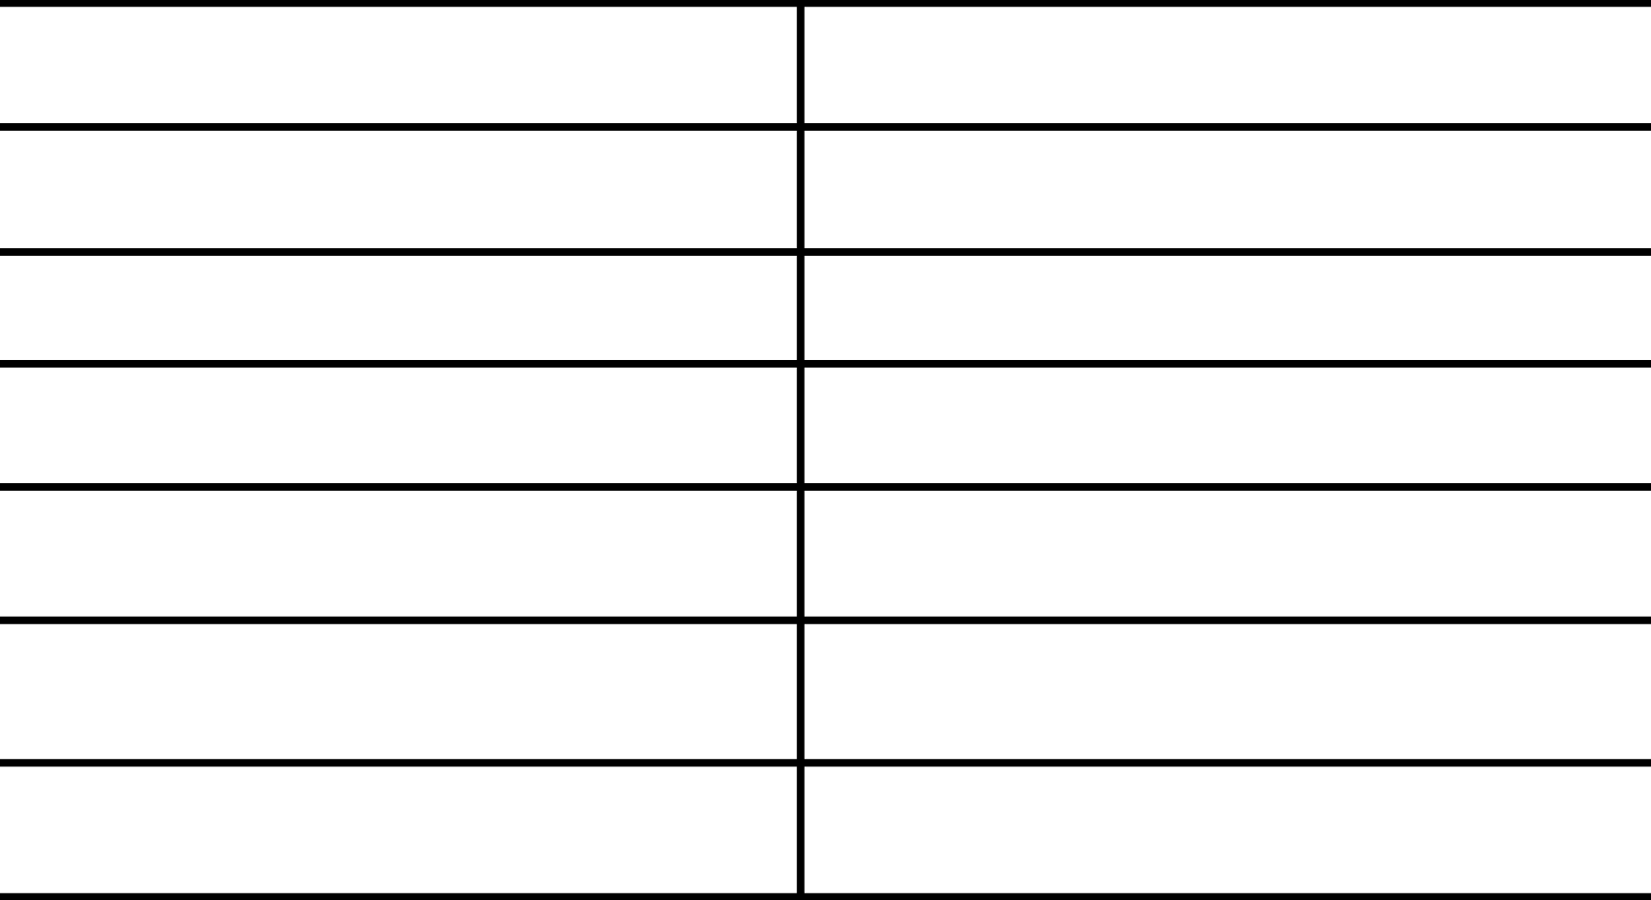

Team Id – 37

TA – Radwa Mostafa

Team Members

20191700729

20191700165

20191700728

20191700730

20191700732

20191700740

20191700742

ھﺎدى اﻳﮭﺎب رﺟﺎء اﺣﻤﺪ

اﻳﻪ ﻣﺤﻤﺪ ﻋﺒﺪاﻟﻌﺰﻳﺰ اﺑﺮاھﯿﻢ

وﺳﯿﻢ ﻋﺒﺪه ﻓﺘﺤﻰ ﻋﺒﺪه

ھﯿﺜﻢ ﻣﺤﻤﻮد اﻟﺴﯿﺪ ﻣﺤﻤﻮد

ھﺎﻧﻰ ﻣﺤﻤﺪ ﺳﯿﺪ اﺣﻤﺪ

ھﺎدى ﻋﺎطﻒ ﺳﯿﺪ ﻣﺤﻤﺪ

ھﺎدى اﺣﻤﺪ ﻋﺒﺪ اﻟﺴﻼم

Contact us via

[hady20191700728@cis.asu.edu.eg](mailto:hady20191700728@cis.asu.edu.eg)

Contents

1- Introduction: 3

2- Context Diagram: 3

3- User Requirements: 3

4- Functional Requirements: 4

Choosing language: 4

Searching for medicine: 4

Displaying medicine details: 4

User’s cart: 4

Adding to cart 4

More than one address: 5

Connecting to nearest pharmacy: 5

Way of Payment: 5

Admin Management: 5

5- Non-Functional Requirements: 5

6- Use case: 6

7- Sconce Diagram: 6

# Introduction:

“Belshifa” is an application which has been developed to provide users with a flexible medicine ordering service. It allows users to search for the required medicine and attaching any info regarding the required medicine to avoid mistakes. After ordering, the system searches for the nearest pharmacy having the required medicine to connect to it and fasten the delivery process.

# Context Diagram:

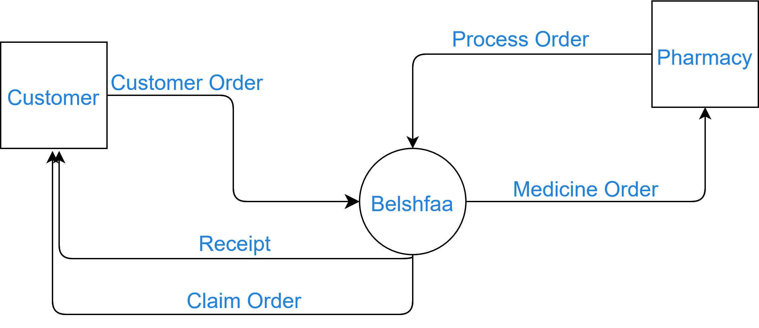

# User Requirements:

* The system should be localized to support more than one language at least English and Arabic.
* The system should allow the user to log in and register to the system and login as a guest if he is not registered.
* The system should be user friendly.
* The user should be able to search for the medicine by more than one way
  + Category
  + Name
* The user should be able to buy more than one item at a time (using cart)
* The user should be able to add his address and other addresses if he wants to
* The System should allow the user to add to his cart the medicine picture or the Doctor prescription
* The system should allow the user to pay by either way:
  + Cash on delivery
  + Credit
* After the user purchases his/her items, the system should connect to the nearest pharmacy and checks the availability of the medicines and place the shipment

# Functional Requirements:

## Choosing language:

* + Description: The system shall allow users to choose their language.
  + Source: User
  + Input: User chooses Arabic or English
  + Pre-Condition: The user clicks on the “change language” button
  + Post-condition: The application language has been updated
  + Output: “Language has been updated successfully” message is displayed for the user

## Searching for medicine:

* + Description: The system shall allow the user to search for medicine in more than one way
  + Source: User
  + Input: Enter medicine Name or select a category
  + Pre-Condition: The user clicks on the “search for medicine” icon or chooses from the categories list
  + Output: Displays the search results

## Displaying medicine details:

* + Description: The system shall allow the user to preview the medicine description.
  + Source: System
  + Input: User searches for a medicine or chooses a category.
  + Output: Displaying the medicine name, price, and alternatives of the shown medicines.

## User’s cart:

* + Description: The system shall give each user a cart.
  + Source: System
  + Pre-Condition: the user is logged in or registered

## Adding to cart

* + Description: The system shall allow the user to add to his/her cart
  + Source: User
  + Input: -User enters one of these requirements:
    - Medicine from the search list
    - Medicine from the category list (or product)
    - Photo for a medicine from the gallery
    - Photo of medicine from the camera
    - Photo for a Doctor's prescription
  + Pre-Condition: The user is logged in or registered with defined address.
  + Output: The cart containing the required medicines.

## More than one address:

* + Description: The system shall allow the user to add more than one address and allow him choose each time one of these addresses.
  + Source: User
  + Pre-Condition: User is logged in or registered
  + Post-Condition: Address is added to the user profile info to be viewed by the delivery representatives.
  + Output: Display a window saying that the addresses are entered successfully

## Connecting to nearest pharmacy:

* + Description: After the user proceeds, the system should connect with the nearest pharmacy to check the availability of required medicine(s).
  + Source: System
  + Pre-Condition: The medicine is added to the cart & user clicked on “Confirm” button.
  + Output: Notify the user that the medicine(s) is ready for shipment with the expected delivery date.

## Way of Payment:

* + Description: The system shall give the user the choice of whether to pay by credit or cash on delivery
  + Source: User
  + Pre-Condition: If the user has chosen the way of payment successfully with a non-empty cart.
  + Output: Displays the receipt.

## Admin Management:

* + Description: The system shall have at least one admin account to track and update medicine data that common user can view.
  + Source: System
  + Pre-Condition: The admin logs in.
  + Post-Condition: Database is updated.
  + Output: Display Success message

# Non-Functional Requirements:

* The system must support at least two languages.
* The system must respond to the user’s search in less than 1 second.
* The system must have at least 1 TB of storage to store medicine info.
* The system provides the single user with one cart.
* The system must have at least one address from the user to deliver products.
* The system must check the availability in less than 5 minutes with the nearest pharmacy.
* When the medicine becomes available, the system should notify the user in less than 1 second.
* The system must provide multiple methods of payment.
* The system should add the new order to the shipping queue in less than 2 seconds to deliver it to the user in less than 2 hours.
* The system should be user-friendly and the user needs at most one 6 hours to get familiar with the application.

# Use case:

# Sconce Diagram: